Project: Cultural Heritage & Promotion of Understanding in PUNJAB
Supported by: UNESCO-UNDP
INTERNATIONAL YEAR FOR THE CULTURE OF PEACE-2000
UNESCO’s Cultural of Peace Program
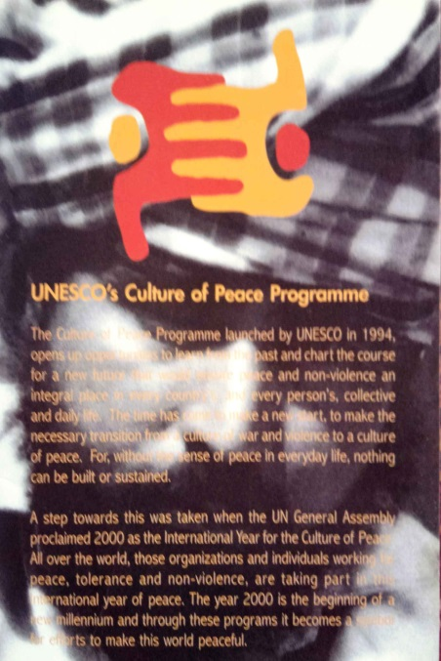
Project Awarded: International South Asia Peace Award-2000
The Culture of Peace program launched by UNESCO in 1994 open up opportunities to learn from the past and chart the course of new future that would ensure peace and non-violence an integral place in every country and every person’s collective and daily life. The time has come to make new start, to make the necessary transition from culture war and violence to a culture of peace. For without the sense of peace in everyday life, nothing can be building or sustained.
A step towards this was taken when the UN General Assembly proclaimed 2000 as the international year for the Culture of Peace. All over the world, those organization and individual working for peace, tolerance and non-violence, are taking part in this international year of peace. The year 2000 is the bringing of new millennium and though these programs it becomes symbol for efforts to make this world peaceful.
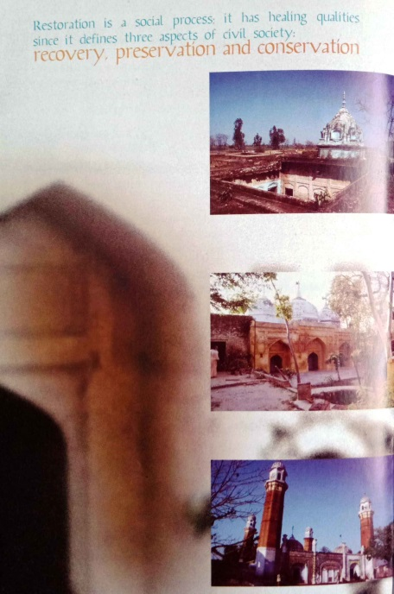
Restoration is a social process; it has healing qualities since it defines three aspects of civil society. Recovery,Preservation and Conservation.
Restoration as a social Process.Sacred sites that cut across religious boundaries.
The secular cultural traditions of Punjab are nowhere more exemplified that in the life and time of three religious sites chose by CRCI for its project located in different settlements of the Gurdaspur peaceful co-existence of different ways of district, these sites are inhabited by Hindus, Christians and the Sikhs who are the largest community the temple in kishankot is today being looked after by the Silk community the mosque on the River Beas, is being maintained by the Nihangs- asect of the Sikhs and the Dargah of Muslim saint being cared for the Christian and other communicated of the neighborhood.
These scared places stand silent testimony to the harmonious relations between a man and different religious in modern times theysymbolize the peaceful co-existence of different ways of looking at the works, in a land carelessly ravaged by partition and terrorism in the no s distant past.
Krishant Temple: located in the village of Kishankot, this temple was built during the region of the legendary Sikh Maharaja RanjitSingh the wall painting within depict a harmonious blend of range of themes concerned with Hindu gods and goddesses. The fabled poet kabir, the 10the Sikh Gurus and courtsscenes from Ranjit Singh court. As mentioned earlier the temple is being looked after the Sikh community living around it.
Guru Ki Masjid: This 17the Century mosques, on the banks of the river Beas, was built by the 6th Sikh Shri.Hargovindpur for his Muslim subjects. Legend has it that the Hindu God Viswakarmacame down to earth in human form to build this scared town of Sri Hargovindpur for Many years, this mosque has been maintained by the Nihangs.

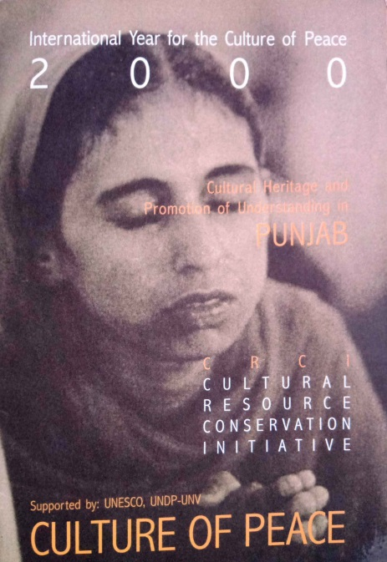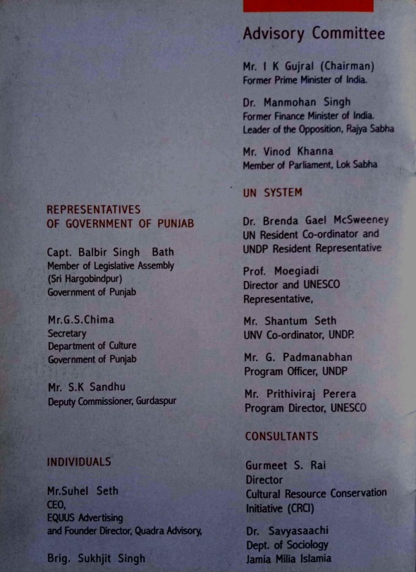

Since wars begin in the minds of men, it is in the minds of men that the defences of peace must construct.”
Constitution of UNESCO, 1945
What is culture of Peace?
The culture of peace is all values, attitudes and forms of behaviors that reflect respect for life, for human beings and their dignity and for allhuman rights, the rejects of violence in all its forms and commitment to the principles of freedom, justice, solidarity, tolerance and understanding among people and between groups and individual.
WE MUST
- Encourage education for peace, human rights and democracy, tolerance and international understanding
- Protects and respect all human right, without except, and combat all forms of discrimination
- Promote democratic principles at all level of society:
- Live in tolerance and solidarity
- Combat poverty and ensure endogenous and sustainable development for the good of all, cable of providing every- one with the quality of life that is consistent with human dignity
- Protect and respect our environment
PROJECT SCOPE
- Identification and documentations of cultural sites in 2 districts of Punjab( work in 7 other districts has already been completed)
- The recovery of the material and symbolic aspects of the cultural heritage at the selected sites as integral to the process of sustainable development
- Dialogue and interactions with people to identify third skills and understand the social dimensions of their lives through:
- Cultural events, theater programs and workshops
- Craft development programs.
- A film to explore and document the social process of restoration and
- Documenting theprogramme on the files.

Examination Report
Kishankot wall painting,Kishankot,Punjab
Style fresco-Bruno (fresh plaster)
These panels are more discoloration and production of various color compounds by fungi causing staining which may seriously impairs and chromatic and aesthetic appeal of the painting. Black, Green, red brown, white stains, etc.
Dust and dirt collected on the painting absorbs moisture and it turn attract micro pores. The droppings of first are feeding sources for the microorganism. The micro-organism responsible for the mild growth is usually of the fungi.
Graphic Documentation.
This process is beginning with details of the wall, which is containing many problems due to many reasons like bio deterioration, microorganism.
So far we have documented 20 problems in painting which is exist and we can see easily by naked eyes but somewhere we have to used lens to get confirmed the problems. We are tracing out problems by giving particulars symbols and sings to so that we can identify with colors and typical symbols. We have registered the some color pencils for each problem and we are keeping so on.
Doing chemical conservation, we have to vary careful while doing cleaning or using chemical one should know how should be le and what to be clean in what extents perhaps we have tested some areas in painting i.e. patch test with some chemicals like acetone, toluene, ammonia and so on. We have found that all chemical are giving different result on difference spaces of colors. Here, we have to be very careful while cleaning the color areas. Some color and are soluble and so we are not. We don’t have fixed any chemical compositions techniques to clean area yet.
So, we have finished important photo documentation process .we have to locate the problems very minutely and tracing approximately on tracing papers right now.we have are working in before restoration process. After completely one whole documentations, maintain another problem sheets during restoration.
- Mentioning the testing of problems sheets
- With the examined here soot of dust and dirt soot’s, mosses, salts accretion fungus deposited on painting.
- The test only to find of problems bust we do the real process of conservations first consolidate, blisters air pockets and flaking, then second we solve the structural conservations which check the wall outside and roof. Which should be properly covered by waterproof plaster, upon the painting? First we clean surface dust. The second remove of surface dust then clean sticking material and dirt and root and non-ionic detergent and with spirit.
- Then we removed slat accretions upon the painting.
- Then we removed very strong tricky materials with little strong solvents.
- Again we check all the air pockets and flaking should be properly consolidate. Finally, we apply preservative coating then all gaps should be filled with putty then.
Factor favoring microbiological growth on wall painting.
- Effect of visitor- dispersal of fungal spores by the visitors by the respiration Co2 with H2O formed Hxco3
- Effect of vegetation higher plants on the building where wall painting present- moisture wall etc.
- Relative humidity- 70%- 95% RH
- Temperature 25-35 C
- Availability of nutrition
Plaster cellulose starch etc., into ground, paint layer glue etc., dust and dirt, binding medical of paint, restoration materials egg yolk etc. If the materials used in restoration process are organic in nature in some cases, the materials used for the conservations treatment one of the source of fungal growth.

Environmental Pollution: The existence of hydro chambers and volatile organic compounds in atmosphere, emitted by the oil refineries and cellulose pulp plant can deposit on the painting and form a layer of organic compounds able to support the growth of microbes. Later conditions also help for growth of fungi cladosporim, aspergillum, pencillium.

Bat & Pigeons excreta.
Provide nutrition’s for the proliferations of fungi.
Fungal form flora on wall painting in temperature climate: aureotadium, pollutants, cladospriums, herbarium. Exterior paint surface: alternainpencillium, aspergillums

Effect of fungal growth on wall paintings.
Discolorations of the wall painting surface: by the productions of various coloured compound by fungi causing strain which may seriously impair the chromatic and aesthetic appeal of the painting .black, green, red brown white stains etc.

Tempera- After cleaning lime plaster, Wall painting generally classified into
Tempera, fresco, Sacco
Depending upon the techniques of execrations support and ground and paint layers

Fresco Bunno: In fresco painting, paint was applied on wet line calcium carbonate favored in the cores of drying of plaster consolidated the pigment particles.
No glues or binding materials used in this technique.
In fresco techniques, only mediums used for binding of pigments therefore should not attacked by microns.
But there are many examples where fungal growths have been reported form fresco.
In case of fresco, the nutritious requirements are met by the presence of organic compounds in dust layer which has cumulated over the paintings.

Dust/ dirt: capable of retaking moistures on the surface of the paintings which attack fungal spore’s pollination also provides neutrinos of growth. Animal excreta pigeons, birds rats, excreta also provide nutrition to fungal because there are organic natural materials.

Tempera: Ground organic nature composed of vegetable fibers rice bucks and organic material in binding used glues etc. They provide nutrition to fungal growth Fungi, bacterial actinory cites, algae, lacuna Chlorpyeles, sunlight auto topic microganics, humidity high above 85% presence of sunlight preserve of cholrhyell and inorganic components (paints).

